**RELATIONSHIP IN DAX**

**1.RELATED:** Can be used to refer to any column/s in any table as long as there is a model relationship created at the model view

* Returns scalar/single value i.e column
* NB: Related works only in **many to one relation** i.e sem1_score can get data from from roll number but roll number cant get data fromsem1_score
* related col2 = RELATED(RollNo[Roll No])

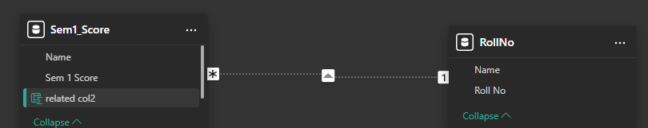

Other more examples:

Related = RELATED('Calendar'[Network])

fetch col = RELATED(RollNo[Roll No])

Related advance = IF(RELATED('Distinct'[Pizza_Name])="Deluxe",1,0)

**CREATING TABLE USING FILTER & RELATED**

Table = FILTER(PizzaSales,RELATED('Distinct'[Pizza_Name])="Farmhouse")

**2.RELATEDTABLE**

* Returns table
* Can work in 1-1, 1- many, many-1 relationships its not limited
* Related table2 = SUMX(RELATEDTABLE(Sem1_Score),Sem1_Score[Sem 1 Score])
* To use related table ensure you CLUB WITH ITERATIVE FUNCTIONS OR USE TO CREATE STANDALONE TABLE i.e example SUMX, COUNTROWS etc

related table = SUMX(RELATEDTABLE(RollNo),RollNo[Roll No])

**3.CROSS FILTER**